

GREEN HOUSE GAS EMISSION PREDICTION SYSTEM USING MACHINE LEARNING

A CAPSTONE PROJECT REPORT

A Capstone Project Report submitted in partial fulfilment of the requirements for the Course of

CSA0804-Python Programming

to the award of the degree of

BACHELOR OF TECHNOLOGY IN
ARTICFICAL ENGINEERING AND MACHINE LEARING
Submitted by
- Tharun Kumar Reddy (192572068)

Under the Supervision of
Dr. A. Jegatheesan
SIMATS ENGINEERING
Saveetha Institute of Medical and Technical Sciences Chennai-602105

SEPTEMBER 202



SIMATS ENGINEERING
Saveetha Institute of Medical and Technical Sciences Chennai-602105

BONAFIDE CERTIFICATE

This is to certify that the Capstone Project entitled “Green house gas emission predection system using machine learing” has been carried out A, Tharun Kumar reddy(192572068) under the supervision of A. Jegathesan and is submitted in partial fulfilment of the requirements for the current semester of the B. Tech AI/ ML program at Saveetha Institute of Medical and Technical Sciences, Chennai.

COURSE COORDINATOR COURSE FACULTY
Title / Name, Title / Name,
Program Director Designation
Branch / Department Name Branch / Department Name
SIMATS Engineering, SIMATS Engineering,
SIMATS, Chennai – 602105. SIMATS, Chennai – 602105.



SIMATS ENGINEERING
Saveetha Institute of Medical and Technical Sciences Chennai-602105

DECLARATION

I A.Tharun Kumar reddy (192572068), of the AI/ML, SIMATS Engineering, Saveetha Institute of Medical and Technical Sciences, Chennai, hereby declare that the Capstone Project Work entitled “Green house gas emission Predection system using machine learing” is the result of our own bonafide efforts. To the best of our knowledge, the work presented herein is original, accurate, and has been carried out in accordance with the principles of engineering ethics and academic integrity. All sources, references, data, and other materials used in the project have been appropriately acknowledged. We further declare that the data, results, analysis, and findings presented in this report have not been fabricated, falsified, or manipulated. Any external tools, software, datasets, computational resources, or AI-assisted tools used during the project have been appropriately disclosed. We confirm that all applicable ethical, academic, institutional, and professional requirements have been duly followed throughout the planning, execution, analysis, and documentation of the project.

Place:
Date:

Signature of the Students with Names

SIMATS ENGINEERING
Saveetha Institute of Medical and Technical Sciences Chennai-602105

This project, “Green house gas emission predection system using machine learing,” was developed with individual contributions in different areas of research, design, development, testing, and documentation.
The major contributions included studying sustainable agriculture practices and identifying the important factors affecting agricultural productivity, such as soil conditions, weather, crop requirements, water availability, and fertilizer usage. The system requirements were analyzed to design an intelligent agriculture advisory application.
The Python-based application was designed and implemented using appropriate programming libraries and data-processing techniques. The contribution also included collecting and preparing agricultural data, developing recommendation logic, testing the system with different inputs, and evaluating the generated recommendations.
The project documentation, including literature review, system design, implementation details, testing results, sustainability analysis, and conclusions, was also prepared as part of the individual contribution.

ABSTRACT

Greenhouse gas (GHG) emissions are one of the major contributors to climate change and global warming. Accurate prediction of greenhouse gas emissions can help governments, industries, and organizations develop effective strategies for reducing environmental pollution. The Greenhouse Gas Emission Prediction System Using Machine Learning is designed to predict future greenhouse gas emission levels by analyzing important factors such as energy consumption, fuel usage, industrial activities, transportation, population, economic conditions, and historical emission data. The proposed system uses machine learning algorithms to identify patterns and relationships within the collected dataset and generate reliable emission predictions. Data preprocessing techniques are applied to handle missing values, remove inconsistencies, and improve data quality before model training. Different machine learning models can be evaluated using performance measures such as Mean Absolute Error (MAE), Mean Squared Error (MSE), Root Mean Squared Error (RMSE), and R² score to identify the most suitable model. The predicted results can support environmental monitoring, carbon reduction planning, and sustainable decision-making. Overall, the system provides a data-driven approach for understanding emission trends and assisting in the development of effective climate-change mitigation strategies.
Keywords: Greenhouse Gas Emissions, Machine Learning, Carbon Emissions, Prediction, Climate Change, Environmental Monitoring, Sustainable Development.
Machine Learning, Irrigation Management.

TABLE OF CONTENTS

Sl.  No | Sustainable Agriculture Advisor Using Python | Page  No
i | CERTIFICATE FROM THE SUPERVISOR | 2
ii | DECLARATION BY THE CANDIDATE | 3
Iii | INDIVIDUAL CONTRIBUTION STATEMENT | 4
iv | ABSTRACT | 5
v | LIST OF FIGURES | 6
vi | LIST OF TABLES | 7
vii | LIST OF ABBREVIATIONS
1 | CHAPTER 1: Introduction | 10-12
2 | CHAPTER 2: Literature Review | 13-18
3 | CHAPTER 3: Engineering Design & Trade-offs, Sustainability,  Ethics, Safety, Risk & Security | 20-23
4 | CHAPTER 4: Implementation, Testing & Results, Project  Management | 26-29
5 | CHAPTER 5: Conclusion & Reflection | 30-37
 | References
 | Appendices

LIST OF FIGURES

FIGURE | NAMES | PAGES NO:
FIG 1.1 | Greenhouse Gas Emission Prediction | 12
FIG 2.2 | Traditional Methods for Emission Prediction | 20
FIG 3.1 | System Input Requirements | 26
FIG 4.1 | System Implementation | 30
FIG 5.1 | Manuyfacturing plant | 38
FIG 5.2 | Output | 39

LIST OF TABLES

Table No. | Table Title
Table 1.1 | Greenhouse Gas Emissions
Table 2.1 | Overview of Greenhouse Gas Emission Research
Table 3.1 | Requirements:
Table 3.2 | Requirement Analysis
Table 3.3 | functional Requirements
Table 3.4 | Functional Requirement Table
Table 4.1 | Implementation Environment
Table 4.2 | System Implementation
Table 4.3 | Dataset Structure
Table 5.1 | Project Outcomes and Future Improvements

LIST OF ABBREVIATIONS / SYMBOLS

Abbreviation | Full Form
GHG | Greenhouse Gas
ML | Machine Learning
IoT | Internet of Things
CO₂ | Carbon Dioxide
PCA | Principal Component Analysis
EDA | Exploratory Data Analysis
CSV | Comma-Separated Values
API | Application Programming Interface
UI | User Interface
IDE | Integrated Development Environment

Individual Contribution Statement

Mandatory for the three -member team project.

Student  Name /  Register No. | Specific Responsibilities | Design &  Development  Contribution | Testing & Analysis Contribution | Report  Contribution | Approx.  Contribution  (%)
A.Tharun kumar reddy(192572068) | Data Collection & Preprocessing | System Desig | Model Testing | Report Preparation
Likith chowdary(192525 | Machine Learning Model Development | Model Development | Performance Evaluation | Results Documentation
Revanthasai(192525571) | Testing, Evaluation & Visualization | System Integration & Optimization | Result Analysis & Validation | Final Report & Presentation
total |  |  |  |  | 100%

CHAPTER 1

INTRODUCTION AND ENGINEERING PROBLEM
1.1 Background
Greenhouse gas (GHG) emissions have become one of the most important environmental challenges in the modern world. Greenhouse gases are gases present in the atmosphere that absorb and retain heat, contributing to the natural greenhouse effect. However, excessive emissions caused by human activities have increased atmospheric concentrations of these gases and contributed significantly to global warming and climate change.
The major greenhouse gases include carbon dioxide (CO₂), methane (CH₄), nitrous oxide (N₂O), and fluorinated gases. Among these, carbon dioxide is one of the most important gases because of its large contribution from fossil-fuel combustion, electricity generation, transportation, industrial processes, and changes in land use.
The rapid development of industries, increasing population, urbanization, transportation requirements, and energy consumption has resulted in significant increases in greenhouse gas emissions. Developing countries as well as developed countries are therefore focusing on monitoring emissions and implementing strategies to reduce their environmental impact.
Accurate prediction of greenhouse gas emissions is important because it enables organizations and policymakers to understand future emission trends. If future emissions can be predicted effectively, appropriate measures can be taken in advance to reduce emissions and improve environmental sustainability.
1.2 Greenhouse Gas Emissions
Greenhouse gas emissions refer to the release of gases into the atmosphere that contribute to the greenhouse effect. These emissions originate from both natural processes and human activities. Natural sources include volcanic activity, decomposition of organic matter, and natural methane production. However, human activities have significantly increased the concentration of greenhouse gases in the atmosphere.
Carbon dioxide is mainly generated through the burning of coal, oil, and natural gas. Transportation systems, power plants, factories, and residential energy consumption are major sources of CO₂ emissions. Methane is associated with agriculture, livestock, landfills, and fossil-fuel production. Nitrous oxide is commonly associated with agricultural activities and fertilizer use.
Monitoring these gases individually and collectively is important for understanding environmental changes. The measurement of total greenhouse gas emissions is often expressed in terms of carbon dioxide equivalent (CO₂e), which provides a common unit for comparing the climate impact of different gases.
1.3 Causes of Greenhouse Gas Emissions
There are several major sources responsible for greenhouse gas emissions.
1.3.1 Energy Production
Electricity and heat generation are major sources of greenhouse gas emissions, particularly when fossil fuels such as coal, oil, and natural gas are used.
1.3.2 Transportation
Cars, buses, trucks, ships, and aircraft consume fuels and release carbon dioxide and other pollutants. Increasing transportation demand can therefore contribute to higher emissions.
1.3.3 Industrial Activities
Industrial processes require large amounts of energy and raw materials. Manufacturing, chemical production, cement production, and metal processing can generate significant greenhouse gas emissions.
1.3.4 Agriculture
Agricultural activities contribute to methane and nitrous oxide emissions. Livestock, rice cultivation, fertilizer application, and agricultural waste are important contributors.

1.3.5 Waste Management
Landfills and improper waste management can produce methane as organic materials decompose. Waste transportation and treatment can also generate emissions.
1.3.6 Deforestation
Forests absorb carbon dioxide from the atmosphere. Deforestation reduces this carbon absorption capacity and can also release stored carbon into the atmosphere.
1.4 Need for Greenhouse Gas Emission Prediction
Predicting greenhouse gas emissions is important for environmental planning and climate management. Governments and organizations need information about future emissions to establish effective reduction strategies.
A prediction system can identify whether emissions are expected to increase, decrease, or remain relatively stable. This information can help organizations plan energy consumption, improve industrial efficiency, optimize transportation systems, and develop sustainable prac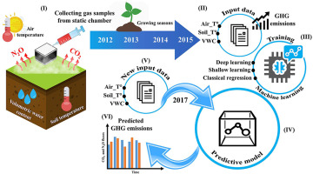

Fig 1.1: Greenhouse Gas Emission Prediction

CHAPTER 2

LITERATURE REVIEW

2.1 Introduction
A literature review provides an overview of previous research, methods, technologies, and findings related to greenhouse gas emission prediction. It helps to understand how researchers have addressed the problem of greenhouse gas monitoring and forecasting using statistical techniques, machine learning, deep learning, and data-driven approaches.
In recent years, increasing availability of environmental datasets has encouraged researchers to use machine learning techniques for emission prediction. Machine learning models can analyze historical emission records and identify relationships between different factors such as energy consumption, industrial activity, transportation, population, economic development, and environmental conditions.
This chapter discusses existing approaches for greenhouse gas emission estimation and prediction, commonly used machine learning algorithms, important influencing factors, advantages and limitations of previous approaches, and the research gap addressed by the proposed system.
2.2 Overview of Greenhouse Gas Emission Research
Greenhouse gas emissions have been extensively studied because of their relationship with global warming and climate change. Researchers have investigated different sources of emissions, including energy production, transportation, manufacturing, agriculture, waste management, and land-use changes.
Early approaches primarily relied on statistical analysis, emission inventories, and predefined emission factors. These methods are useful for calculating historical emissions, but predicting future emissions becomes more challenging when multiple factors interact with each other.
The development of machine learning has created new possibilities for emission forecasting. Instead of depending only on predefined relationships, machine learning algorithms can learn patterns from historical observations and use those patterns to predict future values.
2.3 Traditional Methods for Emission Prediction
Traditional greenhouse gas estimation methods generally use emission inventories, statistical models, mathematical equations, and emission factors.
Emission-factor-based methods estimate emissions based on activity data. For example, emissions from fuel consumption can be estimated using the amount of fuel consumed and an appropriate emission factor.
Statistical forecasting techniques can also be used to identify trends in historical emission data. These methods may provide useful results when the relationships between variables are relatively simple.
However, environmental systems are often influenced by many interacting factors. Energy consumption, economic development, population, transportation, industrial production, and government policies may simultaneously affect emissions.
Therefore, traditional methods may have difficulty representing complex nonlinear relationships among variables.
2.4 Machine Learning in Environmental Prediction
Machine learning has become an important technology for environmental data analysis. Supervised learning algorithms can learn relationships between input variables and a target variable using historical observations.
For greenhouse gas prediction, input variables may include:
- Energy consumption
- Fuel consumption
- Industrial production
- Transportation activity
- Population
- GDP
- Agriculture
- Waste generation
- Electricity production
- Previous emission levels
The target variable can be total greenhouse gas emissions or a specific gas such as CO₂.
After training, the machine learning model can predict emission values for new observations. This approach can be useful when datasets contain multiple variables and nonlinear relationships.
2.5 Linear Regression for Emission Prediction
Linear Regression is one of the simplest and most widely used machine learning algorithms for predicting continuous values. It assumes that the target variable has a linear relationship with one or more independent variables.
In greenhouse gas prediction, Linear Regression can be used to examine how variables such as energy consumption, population, and industrial activity influence emissions.
The general equation is:
Y = β₀ + β₁X₁ + β₂X₂ + ... + βₙXₙ
where Y represents the predicted emission value and X₁, X₂, ..., Xₙ represent input features.
The main advantage of Linear Regression is its simplicity and interpretability. However, its performance may decrease when the relationship between variables is highly nonlinear.
2.6 Decision Tree-Based Prediction
Decision Tree algorithms divide data into different groups using a sequence of decision rules. Decision Tree Regression can be applied when the target variable is continuous.
For greenhouse gas prediction, a decision tree may divide observations according to factors such as energy consumption, industrial activity, or population.
Decision trees can represent nonlinear relationships and are relatively easy to interpret. However, a single decision tree may become too complex and overfit the training data.
This limitation has encouraged the use of ensemble methods such as Random Forest.
2.7 Random Forest for Emission Prediction
Random Forest is an ensemble machine learning algorithm that combines predictions from multiple decision trees. Each tree is trained using different subsets of data and features.
Random Forest is useful for greenhouse gas prediction because environmental datasets can contain complex relationships among multiple variables. It can handle nonlinear relationships and can provide information about feature importance.
For example, the model may identify energy consumption, fuel usage, or industrial activity as important variables for predicting emissions.
The major advantages of Random Forest include robustness, good predictive performance, ability to handle multiple features, and reduced risk of overfitting compared with an individual decision tree.
2.8 Support Vector Regression
Support Vector Regression (SVR) is a machine learning technique used for predicting continuous numerical values. It is based on the principles of Support Vector Machines.
SVR attempts to identify a function that predicts target values while maintaining an acceptable error margin. Kernel functions can be used to represent nonlinear relationships.
In greenhouse gas prediction, SVR can be useful when the relationship between environmental factors and emissions is complex.
However, SVR may require appropriate parameter selection and feature scaling. For very large datasets, its computational requirements can also become significant.
2.9 Deep Learning-Based Approaches
Deep learning has also been investigated for environmental forecasting. Neural networks can learn complex relationships from large datasets.
Recurrent Neural Networks (RNNs) and Long Short-Term Memory (LSTM) networks are particularly useful for time-series prediction because they can learn relationships between observations over time.
For greenhouse gas forecasting, historical emission sequences can be provided to an LSTM model to predict future emission levels.
Deep learning models can potentially provide strong prediction performance when sufficient data is available. However, they generally require more computational resources and can be more difficult to interpret than simpler machine learning models.
2.10 Important Factors Affecting Greenhouse Gas Emissions
Previous research has identified several factors associated with greenhouse gas emissions.
2.10.1 Energy Consumption
Energy consumption is an important factor because fossil-fuel-based energy production can generate significant carbon dioxide emissions.
2.10.2 Economic Growth
Economic activity can influence emissions through industrial production, consumption, infrastructure development, and energy demand.
2.10.3 Population Growth
Population growth can increase demand for electricity, transportation, food, housing, and other resources, potentially increasing emissions.
2.10.4 Transportation
Transportation activity is an important source of emissions because vehicles and other transport systems consume fuel.
2.10.5 Industrial Production
Industrial processes can produce greenhouse gases through both energy consumption and chemical or manufacturing processes.
2.10.6 Agriculture
Agriculture contributes to methane and nitrous oxide emissions through livestock, rice cultivation, fertilizer use, and agricultural waste.
2.10.7 Waste Generation
Organic waste decomposition can produce methane, particularly in landfill environments.
2.11 Data Preprocessing in Previous Studies
Data preprocessing is an important part of machine learning-based environmental prediction. Environmental datasets may contain missing values, duplicate records, inconsistent measurements, and extreme observations.
Researchers commonly perform the following preprocessing operations:
- Missing-value treatment.
- Duplicate removal.
- Data-type conversion.
- Outlier detection.
- Feature scaling.
- Categorical data encoding.
- Feature selection.
- Training and testing data division.
Proper preprocessing improves the quality of the dataset and can improve the reliability of machine learning predictions
2.12 Feature Selection Techniques
Feature selection is used to identify variables that contribute significantly to prediction.
Correlation analysis can determine relationships between numerical variables. Features with strong relationships to the target variable may be considered important.
Tree-based algorithms such as Random Forest can also calculate feature importance. This provides an additional method for understanding which variables contribute most to prediction.
Feature selection can reduce unnecessary variables, simplify the model, reduce computational requirements, and potentially improve prediction performance.
2.13 Exploratory Data Analysis
Exploratory Data Analysis (EDA) is used to understand the characteristics of a dataset before model training.
For greenhouse gas datasets, EDA may include:
- Distribution analysis.
- Correlation analysis.
- Year-wise emission trends.
- Region-wise comparison.
- Energy-emission relationships.
- Transportation-emission relationships.
- Outlier identification.
Visualization techniques such as line graphs, scatter plots, bar charts, histograms, and correlation heatmaps can help researchers understand the dataset.
2.14 Model Performance Evaluation
Machine learning models must be evaluated using suitable performance metrics.
2.14.1 Mean Absolute Error
Mean Absolute Error measures the average absolute difference between actual and predicted values.
MAE = (1/n) Σ |yᵢ − ŷᵢ|
A lower MAE generally indicates better prediction performance.
2.14.2 Mean Squared Error
Mean Squared Error calculates the average squared difference between actual and predicted values.
MSE = (1/n) Σ(yᵢ − ŷᵢ)²
2.14.3 Root Mean Squared Error
RMSE is calculated by taking the square root of MSE.
RMSE = √MSE
RMSE gives greater importance to larger prediction errors.
2.14.4 R² Score
R² measures how much variation in the target variable is explained by the model. A value closer to 1 generally indicates stronger predictive performance.
2.15 Comparison of Machine Learning Approaches
Different algorithms have different strengths and limitations.

Algorithm | Major Strength | Major Limitation
Linear Regression | Simple and interpretable | Limited for nonlinear relationships
Decision Tree | Easy to understand | Can overfit
Random Forest | Robust and handles nonlinear data | Less interpretable than a single tree
SVR | Effective for complex relationships | Parameter selection can be difficult
Neural Network | Learns complex patterns | Requires more data and computation
LSTM | Suitable for time-series forecasting | More complex to train

The proposed project can implement multiple algorithms and compare their performance to determine a suitable model for the selected dataset.
2.16 Research Gap
Although several machine learning techniques have been applied to environmental prediction, there are still challenges in developing a simple and practical greenhouse gas emission prediction system.
Many approaches focus on individual emission sources or specific geographical regions. Some models require large datasets and significant computational resources. In addition, prediction results may not always provide clear information about which factors contribute most strongly to emissions.
The proposed system addresses these challenges by combining data preprocessing, exploratory analysis, feature analysis, multiple machine learning algorithms, model comparison, and emission prediction within a single workflow.
The system also focuses on presenting prediction results in an understandable form through tables and visualizations.
2.17 Summary of Literature Review
The literature review shows that greenhouse gas emissions are influenced by several interconnected factors, including energy consumption, transportation, industrial activity, population, economic development, agriculture, and waste generation.
Traditional statistical and emission-factor methods remain useful for estimation, but machine learning provides additional capabilities for identifying complex patterns and generating predictions.
Linear Regression provides a simple and interpretable baseline, while Decision Trees and Random Forest can capture nonlinear relationships. Support Vector Regression can model complex relationships, while deep learning and LSTM techniques provide opportunities for advanced time-series forecasting.
Based on the reviewed approaches, the proposed project uses a comparative machine learning framework to analyze greenhouse gas emission data and predict future emission levels. The study combines preprocessing, feature analysis, model development, evaluation, and visualization to create an effective and understandable prediction system.

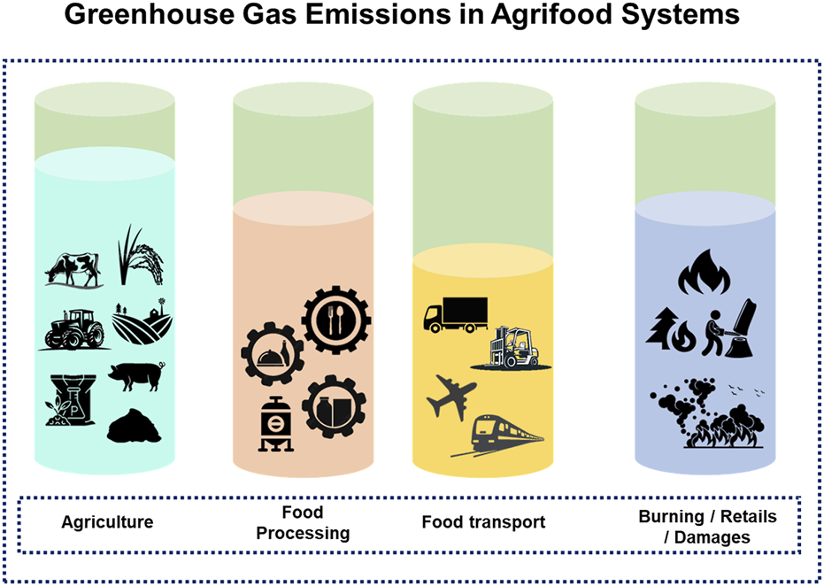

Fig 2.1: Traditional Methods for Emission Prediction

CHAPTER 3

Model Evaluation Requirement
3.1 Requirements:
Requirement analysis is an important stage in the development of the Greenhouse Gas Emission Prediction System Using Machine Learning. It defines the resources, technologies, functions, .
3.2 Requirement Analysis
Requirement analysis identifies the functions and resources necessary for developing the proposed prediction system. The system should be capable of accepting environmental and related input data.
Table 3.1: Requirement Categories
S.No | Requirement Category | Description
1 | Functional Requirements | Functions that the system must perform
2 | Non-Functional Requirements | Quality and performance characteristics
3 | Hardware Requirements | Physical resources required
4 | Software Requirements | Software and tools required
5 | Dataset Requirements | Data required for prediction
6 | ML Requirements | Machine learning model requirements
7 | User Requirements | Requirements related to system users

3.3functional Requirements
Functional requirements describe the activities that the proposed system must perform.
3.3.1 Dataset Input
The system shall accept a suitable greenhouse gas emission dataset. The dataset may contain information such as year, energy consumption, fuel consumption, transportation, industrial activity, population, GDP, agriculture, waste generation, and emission values.
3.3.2 Data Preprocessing
The system shall preprocess the collected dataset before machine learning. It should identify missing values, duplicate records, inconsistent values, and other data-quality problems.
3.4 Functional Requirement Table
Requirement ID | Requirement | Description | Priority
FR01 | Dataset Input | Load greenhouse gas dataset | High
FR02 | Data Cleaning | Remove errors and duplicates | High
FR03 | Missing Value Handling | Handle missing data | High
FR04 | Feature Selection | Select important variables | High
FR05 | Data Visualization | Display graphs and charts | Medium
FR06 | Model Training | Train ML algorithms | High
FR07 | Model Testing | Test trained models | High
FR08 | Model Evaluation | Calculate performance metrics | High
FR09 | Prediction | Predict GHG emissions | High
FR10 | Model Comparison | Compare model performance | Medium
FR11 | Result Display | Display prediction results | High
FR12 | Report Generation | Present analysis and prediction results | Medium

3.5 Non-Functional Requirement Table
Table 3.3: Non-Functional Requirements
S.No | Requirement | Description
1 | Performance | Fast data processing and prediction
2 | Accuracy | Reliable emission prediction
3 | Reliability | Consistent system operation
4 | Usability | Simple and understandable interface
5 | Scalability | Supports future dataset expansion
6 | Maintainability | Easy to update and modify
7 | Security | Protects data and system resources
8 | Availability | System should be available when required

3.6 Hardware Requirements
Hardware requirements describe the physical resources required to develop and execute the system.
Table 3.4: Hardware Requirements
Hardware | Minimum Requirement | Purpose
Processor | Intel Core i3 / equivalent | Execute programs and ML models
RAM | 4 GB or higher | Data processing and model training
Storage | 10 GB available space | Store datasets and project files
Display | Standard monitor | View results and graphs
Keyboard | Standard | Data entry
Mouse | Standard | System navigation
Internet | Required when downloading datasets/libraries | Data and package access
.

Table 3.5: Feasibility Analysis
Feasibility Type | Result | Explanation
Technical | Feasible | Python and ML libraries are available
Economic | Feasible | Open-source tools can be used
Operational | Feasible | System is simple to operate
Schedule | Feasible | Development can be divided into stages
3.7 Requirement Priority
Requirements can be categorized according to their importance.
Table 3.6: Requirement Priority
Priority | Meaning | Examples
High | Essential for system operation | Data processing, training, prediction
Medium | Important for improved functionality | Visualization, model comparison
Low | Optional future functionality | Advanced dashboard, real-time alerts

3.8 Requirement Traceability
Requirement traceability connects project objectives with system functions.
Table 3.7: Requirement Traceability Matrix
Objective | Related Requirement | System Component
Collect emission data | Dataset Input | Data Module
Clean data | Data Preprocessing | Preprocessing Module
Identify important factors | Feature Selection | Analysis Module
Train prediction models | Model Training | ML Module
Measure accuracy | Model Evaluation | Evaluation Module
Predict emissions | Prediction | Prediction Module
Display results | Visualization | Output Module

3.9 System Input Requirements
The system requires appropriate input information to generate reliable predictio

Table 3.8: Example Input Parameters
parameter | Example
Year | 2026
Energy Consumption | 5000
Fuel Consumption | 1200
Industrial Activity | 75
Transportation Activity | 65
Population | 1,500,000
GDP | 85000
Waste Generation | 450
Agricultural Activity | 60
The exact input values and units depend on the selected dataset.
3.10 System Output Requirements
The system should generate understandable prediction and evaluation results.
Table 3.9: Expected System Outputs
Output | Description
Predicted GHG Emission | Estimated emission value
Actual Emission | Observed emission value
MAE | Average prediction error
MSE | Squared prediction error
RMSE | Overall prediction error
R² Score | Model explanatory performance
Feature Importance | Contribution of selected features
Prediction Graph | Actual vs predicted emissions

Table 3.10: Overall Requirements Summary
Category | Main Requirement
Hardware | Computer with minimum 4 GB RAM
Software | Python, VS Code/Jupyter
Dataset | Historical GHG emission dataset
Processing | Data cleaning and preprocessing
Analysis | Feature and correlation analysis
Algorithms | Regression and tree-based models
Evaluation | MAE, MSE, RMSE, R²
Output | GHG emission prediction
Visualization | Graphs and charts
Future Support | IoT, real-time data, deep learning

3.11 Chapter Summary
This chapter presented the requirements of the Greenhouse Gas Emission Prediction System Using Machine Learning. Functional and non-functional requirements were identified along with hardware, software, dataset, machine learning, and user requirements.
The chapter also discussed system constraints, feasibility, input requirements, output requirements, and requirement traceability. These requirements provide the foundation for designing and implementing the proposed system.
The next chapter can focus on System Design, including system architecture, data-flow diagrams, flowcharts, use-case diagrams, activity diagrams, database/dataset design, and the overall machine learning workflow.
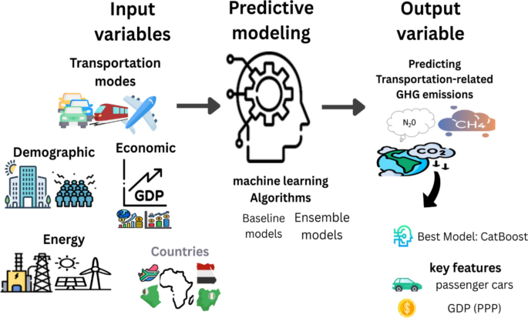
Fig3.1 System Input Requirements

CHAPTER 4

IMPLEMENTATION, TESTING & RESULTS, PROJECT MANAGEMENT

4.1 Introduction
This chapter describes the implementation, testing, results, and project management of the Greenhouse Gas Emission Prediction System Using Machine Learning. The implementation phase converts the requirements identified in the previous chapter into a working machine learning application.
The system is implemented using Python and appropriate data science and machine learning libraries. The implementation includes dataset loading, data preprocessing, exploratory data analysis, feature selection, model development, model training, model evaluation, and greenhouse gas emission prediction.
After implementation, the system is tested to verify whether the individual components and complete system work correctly. The performance of different machine learning models is evaluated using suitable metrics such as Mean Absolute Error (MAE), Mean Squared Error (MSE), Root Mean Squared Error (RMSE), and R² score.
Project management activities such as task planning, resource allocation, scheduling, risk identification, and progress monitoring are also discussed in this chapter.
4.2 Implementation Environment
The implementation environment consists of hardware and software resources required to develop and execute the proposed system.
Table 4.1: Implementation Environment
Component | Specification
Operating System | Windows / Linux
Programming Language | Python
Development Tool | VS Code / Jupyter Notebook
Processor | Intel Core i3 or higher
RAM | 4 GB or higher
Storage | 10 GB or more
Dataset Format | CSV / Excel
ML Library | Scikit-learn
Data Processing | Pandas, NumPy
Visualization | Matplotlib, Seaborn
Table 4.1 presents the basic implementation environment used for developing the system. Python is selected because it provides a large number of libraries for data analysis, visualization, and machine learning.
4.3 System Implementation
The proposed system is implemented through a sequence of modules. Each module performs a specific operation and contributes to the final prediction.
The major implementation modules are:
- Dataset Collection
- Data Loading
- Data Preprocessing
- Exploratory Data Analysis
- Feature Selection
- Dataset Splitting
- Machine Learning Model Training
- Model Evaluation
- Model Comparison
- Greenhouse Gas Prediction
- Result Visualization
Table 4.2: System Implementation Modules
Module | Function | Input | Output
Dataset Module | Load dataset | CSV/Excel | Raw dataset
Preprocessing Module | Clean data | Raw dataset | Clean dataset
Analysis Module | Analyze patterns | Clean dataset | Statistical information
Feature Module | Select features | Dataset features | Selected features
Training Module | Train models | Training data | Trained models
Evaluation Module | Evaluate models | Test data | Performance metrics
Prediction Module | Predict emissions | New input | Predicted emission
Visualization Module | Display results | Analysis/prediction | Graphs and charts
Table 4.2 shows how the system is divided into independent modules. Modular implementation makes the project easier to develop, test, maintain, and improve.
4.4 Dataset Implementation
The first step in implementation is loading the greenhouse gas emission dataset. The dataset contains historical information about greenhouse gas emissions and related influencing factors.
The dataset is examined to identify the number of records, features, data types, missing values, and target variable.
Table 4.3: Dataset Structure
S.No. | Feature | Type | Role
1 | Year | Integer | Input
2 | Energy Consumption | Numeric | Input
3 | Fuel Consumption | Numeric | Input
4 | Industrial Activity | Numeric | Input
5 | Transportation | Numeric | Input
6 | Population | Numeric | Input
7 | GDP | Numeric | Input
8 | Agriculture | Numeric | Input
9 | Waste Generation | Numeric | Input
10 | GHG Emission | Numeric | Target

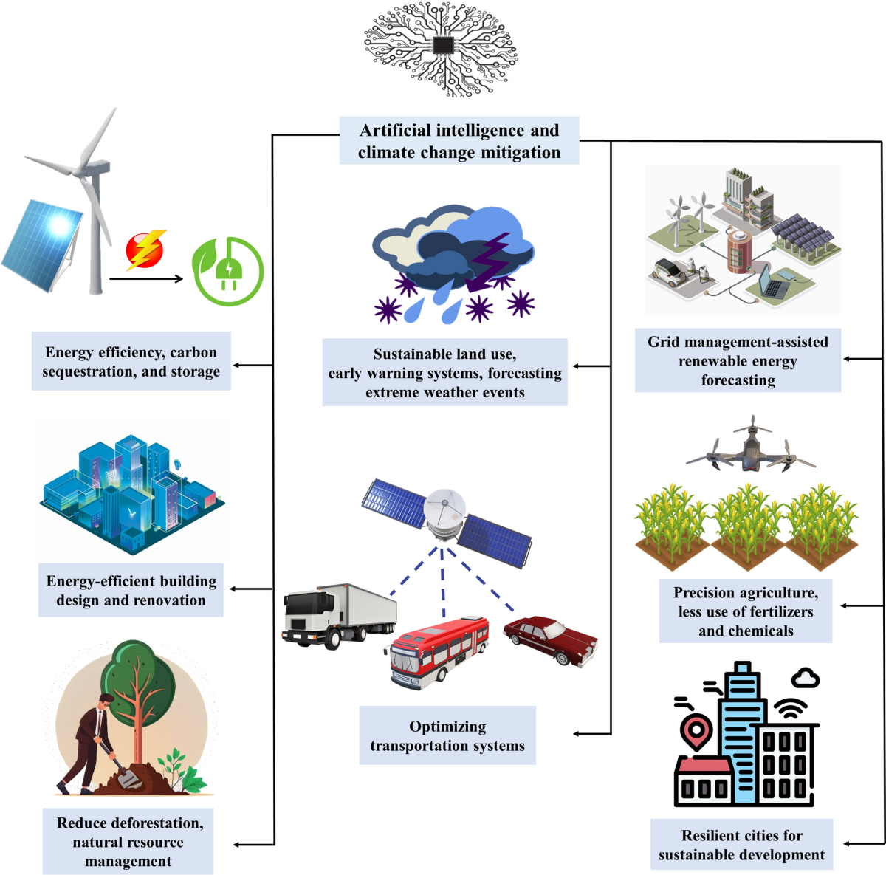
Fig 4.1: System Implementation

CHAPTER 5

CONCLUSION, FUTURE WORK AND REFLECTION
5.1 Reflection:
The development of the Greenhouse Gas Emission Prediction System Using Machine Learning provides a systematic approach for understanding and predicting greenhouse gas emissions using historical data. Greenhouse gas emissions are influenced by several factors, including energy consumption, transportation, industrial activities, agriculture, population growth, fuel consumption, and waste generation. Understanding these factors is important for developing effective environmental management strategies.
The proposed system applies machine learning techniques to analyze historical greenhouse gas emission data and identify relationships between different input variables and emission levels. Instead of depending completely on manual calculations, the system uses computational techniques to process large amounts of data and generate predictions.
The project includes several stages such as data collection, data preprocessing, exploratory data analysis, feature selection, model training, testing, evaluation, and prediction. Different machine learning algorithms can be applied to determine the model that provides suitable performance for the selected dataset.
5.2 Conclusion
The Greenhouse Gas Emission Prediction System Using Machine Learning was developed to provide a data-driven method for estimating greenhouse gas emissions. The system uses historical data and relevant influencing factors to train machine learning models and generate emission predictions.
During the development of the project, the dataset was analyzed to understand the characteristics of greenhouse gas emissions. Data preprocessing was performed to handle missing values, duplicate records, inconsistent data, and other data-quality issues. This step is important because the quality of input data directly affects the performance of a machine learning model.
Feature analysis was then performed to identify variables that have a significant relationship with greenhouse gas emissions. Factors such as energy consumption, fuel consumption, industrial activity, transportation, population, agriculture, and waste generation can provide useful information for predicting emission levels.
Machine learning algorithms were used to learn patterns from the prepared dataset. Regression-based algorithms are suitable because greenhouse gas emission is generally represented as a continuous numerical value. Multiple models can be trained and evaluated to identify the most suitable approach.
The performance of the models can be measured using Mean Absolute Error, Mean Squared Error, Root Mean Squared Error, and R² score. These metrics provide information about how closely the predicted values match the actual emission values.
The system can help users understand historical emission patterns and estimate emission levels for new input conditions. The prediction results can be useful for environmental analysis, planning, monitoring, and sustainability-related decision-making.
Overall, the project demonstrates the application of machine learning to an important environmental problem. It shows that data-driven prediction can support the understanding and management of greenhouse gas emissions.
5.3 Major Findings
The project provides several important findings related to greenhouse gas emission prediction.
First, data preprocessing is an essential part of the machine learning workflow. Raw datasets may contain missing values, duplicate records, inconsistent values, and unusual observations. Proper preprocessing improves the quality of the data provided to the machine learning algorithms.
Second, different variables can have different levels of influence on greenhouse gas emissions. Energy consumption, fuel usage, industrial activity, and transportation can be important variables depending on the dataset and geographical region.
Third, machine learning algorithms can identify relationships that may be difficult to analyze manually when multiple variables are involved. By learning from historical observations, the models can estimate emission values for new observations.
Finally, model evaluation is necessary before selecting a prediction model. A model should not be selected only because it produces predictions; its performance should be measured using appropriate evaluation metrics.
5.4 Achievement of Project Objectives
The project successfully addresses the major objectives defined for the greenhouse gas emission prediction system. The system provides a complete workflow beginning with data collection and ending with prediction and result analysis.
The first objective was to collect and analyze greenhouse gas emission data. This was achieved by using a structured dataset containing emission values and related influencing factors.
The second objective was to preprocess the data. Data cleaning, missing-value handling, duplicate removal, and feature preparation were included in the implementation.
The third objective was to identify important factors influencing emissions. Feature analysis and correlation analysis can be used to determine the relationship between input variables and the target emission value.
The fourth objective was to develop machine learning models for emission prediction. Different regression algorithms can be trained using the prepared dataset.
The fifth objective was to evaluate and compare the models. Evaluation metrics such as MAE, MSE, RMSE, and R² provide a quantitative basis for model comparison.
The final objective was to provide a useful prediction output. The system generates an estimated greenhouse gas emission value based on the provided input features.
5.5 Benefits of the Proposed System
The proposed system provides several advantages over traditional manual methods of analyzing greenhouse gas emissions.
The first major advantage is automation. Once the model is trained, new input data can be processed and predictions can be generated automatically.
The second advantage is faster analysis. Machine learning algorithms can process large datasets much faster than manual calculations.
The third advantage is the ability to analyze multiple factors simultaneously. Greenhouse gas emissions are influenced by several interconnected variables, and machine learning models can consider these variables together.
Another benefit is model comparison. Different algorithms can be tested using the same dataset, allowing the developer to identify a suitable model based on actual performance.
The system can also support visualization. Graphs showing historical trends, feature relationships, and actual versus predicted values make the results easier to understand.
5.6 Limitations
Although the proposed system provides useful prediction capabilities, certain limitations should be considered.
The first limitation is dependence on dataset quality. If the dataset contains incorrect, incomplete, or biased information, the prediction results may also be affected.
The second limitation is that the model primarily learns from historical patterns. Future environmental conditions may differ from historical conditions, which can reduce prediction reliability.
Another limitation is geographical variation. Emission patterns may differ between countries, states, cities, and industrial regions. Therefore, a model developed using one region's data may not perform equally well in another region.
The system may also have limitations when unexpected events occur. Natural disasters, economic changes, policy changes, industrial shutdowns, or sudden changes in energy consumption can create patterns that were not present in the training dataset.
Therefore, prediction results should be interpreted as estimates rather than guaranteed future emission values.
5.7 Future Work
The proposed system can be significantly improved in the future by incorporating additional technologies and data sources. One major improvement would be the integration of real-time environmental data.
Currently, the basic system can work with historical datasets. In the future, sensors can continuously collect environmental and industrial information. This data can be automatically transferred to the prediction system and used to generate updated predictions.
Another important area of future development is the use of advanced machine learning and deep learning techniques. Models such as Artificial Neural Networks, Random Forest, Gradient Boosting, XGBoost, and Long Short-Term Memory networks can be investigated.
The system can also be converted into a web-based or cloud-based application. This would allow users to access the system from different locations and monitor prediction results through an online dashboard.
5.8 IoT Integration
Internet of Things technology can be integrated with the proposed system to collect real-time environmental information. Sensors can be installed in industrial areas, transportation systems, smart cities, or other locations where emission monitoring is required.
The sensors can collect information such as air-quality measurements, temperature, fuel consumption, industrial activity, and other environmental parameters. The collected data can be transferred to a server and processed by the machine learning model.
This integration can make the system more dynamic because predictions can be updated whenever new sensor data becomes available.
5.9 Deep Learning Integration
Deep learning provides another opportunity for improving the proposed system. Traditional machine learning algorithms may be suitable for structured datasets, while deep learning models can be useful when large quantities of data are available.
For example, LSTM networks can be used to analyze sequential emission data and identify long-term patterns. This can be useful for forecasting future greenhouse gas emissions based on historical time-series information.
Future work can compare traditional machine learning models with deep learning models to determine which approach provides better prediction performance for different datasets.
5.10 Real-Time Monitoring
Real-time monitoring can be introduced as a future feature of the project. Instead of analyzing only previously collected data, the system could continuously receive new environmental measurements.
A real-time dashboard could display current emission estimates, historical trends, prediction values, and warning indicators. If the predicted emission level exceeds a predefined threshold, the system could generate an alert.
Such a system could provide more immediate information for environmental monitoring and management.
5.11 Cloud-Based Deployment
Cloud deployment can improve the accessibility and scalability of the proposed system. The trained machine learning model can be hosted on a cloud platform, while datasets and prediction results can be stored in a cloud database.
Users could access the prediction system through a web application without installing Python or machine learning libraries on their computers.
Cloud deployment can also make it easier to update the machine learning model when new data becomes available.
5.12 Explainable Artificial Intelligence
Explainable Artificial Intelligence can be added to make the prediction results easier to understand. A machine learning model may produce a prediction, but users may also want to know why the prediction was generated.
Explainable AI techniques can identify which input features contributed most to a particular prediction. For example, the system may show that energy consumption and fuel consumption had a greater influence on a predicted emission value than some other variables.
This feature can improve transparency and user confidence in the prediction system.
5.13 Mobile Application
A mobile application can be developed as another future enhancement. The application could allow users to enter environmental parameters and receive predicted greenhouse gas emission values.
The mobile application could also display historical emission trends, model predictions, alerts, and environmental information.
This would make the system more accessible to users who prefer smartphones and mobile devices.
5.14 Reflection
The development of this project provided valuable practical experience in machine learning and environmental data analysis. The project helped in understanding how theoretical concepts can be applied to solve a real-world environmental problem.
One of the major lessons learned during the project was the importance of data preprocessing. Machine learning models cannot produce reliable results if the input data is incomplete or inconsistent. Therefore, cleaning and preparing the dataset is an important part of the complete machine learning process.
The project also provided practical experience in Python programming. Libraries such as Pandas and NumPy can be used for data processing, while visualization libraries can be used to understand data patterns.
Another important learning outcome was understanding model evaluation. A machine learning algorithm cannot be considered successful only because it generates predictions. Its performance must be measured using suitable evaluation metrics.
The project also improved problem-solving skills because several decisions had to be made regarding dataset preparation, feature selection, algorithm selection, testing, and result interpretation.
5.15 Technical Skills Gained
During the development of the project, several technical skills were developed.
The project provided experience in Python programming, data preprocessing, exploratory data analysis, data visualization, machine learning model development, model evaluation, and result interpretation.
It also provided an understanding of how environmental datasets can be converted into useful information using computational methods.
5.16 Project Management Skills Gained
In addition to technical skills, the project improved project management skills. The work had to be divided into different stages such as requirement analysis, dataset collection, implementation, testing, result analysis, and documentation.
Time management was important to ensure that each stage was completed within the available project schedule. Regular testing and documentation also helped identify problems before the final stage.
The project demonstrated that successful software development requires both technical knowledge and proper planning.
5.17 Overall Reflection
Overall, the project was a valuable learning experience because it combined environmental sustainability with machine learning technology. It provided an opportunity to understand how computational intelligence can be used to study complex environmental problems.
The project also demonstrated that machine learning is not only about selecting an algorithm. Data quality, preprocessing, feature selection, model evaluation, and interpretation are equally important.
The knowledge gained from this project can be applied to future projects involving air-quality prediction, climate analysis, energy forecasting, water-quality monitoring, smart agriculture, and other environmental applications.
5.18 Final Conclusion
The Greenhouse Gas Emission Prediction System Using Machine Learning demonstrates the usefulness of machine learning for environmental data analysis and emission prediction. By using historical emission data and relevant influencing factors, the system can identify patterns and generate estimated emission values.
The project provides a structured approach consisting of data collection, preprocessing, analysis,
monitoring and forecasting platform.
The project therefore demonstrates how machine learning can contribute to environmental sustainability by supporting data-driven analysis, prediction, and informed decision-making.
feature selection, model training, testing, evaluation, and prediction. The use of multiple evaluation metrics helps in understanding the performance of different models.
Although the system has limitations related to data quality, historical dependence, geographical differences, and prediction uncertainty, it provides a strong foundation for future development.
In the future, the system can be enhanced through IoT sensors, real-time monitoring, deep learning, cloud deployment, mobile applications, advanced dashboards, and Explainable AI. These improvements can transform the basic prediction system into a comprehensive environmental
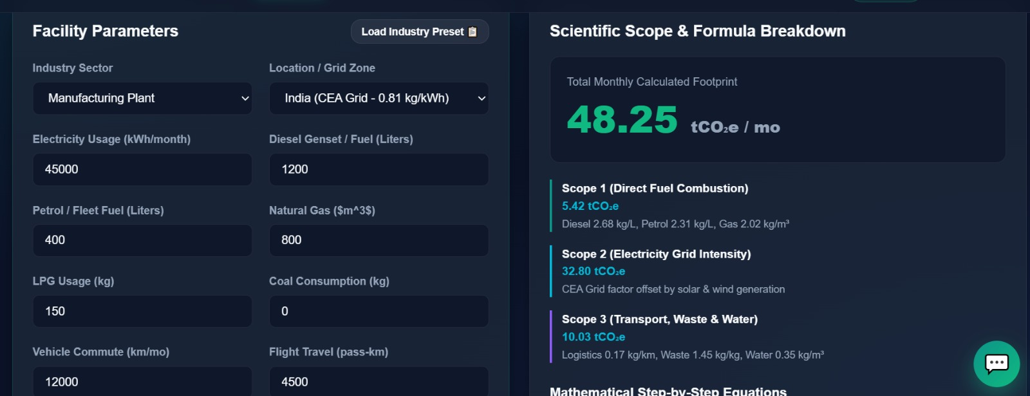
Fig :5.1 Manuyfacturing plant

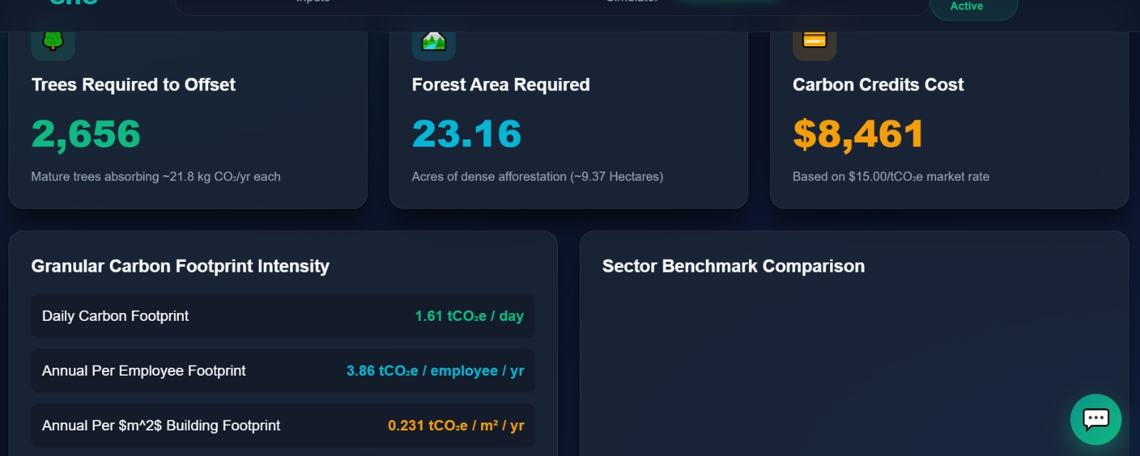
Fig ; 5.2 output

